**Active Learning for Computer Vision Curriculum**

**Project 11 Solution: Generalizations of Active Learning**

**Total Points Possible: 50**

**Problem 1 (50 points)**

Sample outputs are shown below. The correct answer should resemble these outputs.

**Note**: these graphs are from the paper by Chakraborty et al. (discussed in the lecture material). The output may slightly vary depending on the specific entries in the matrix that are deleted and other implementation specifics. These should just be used as references.

i)

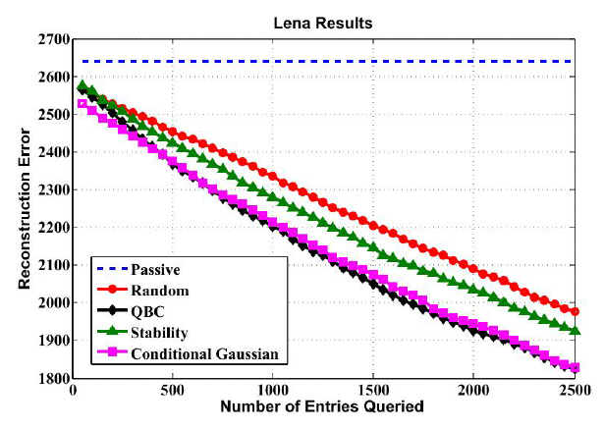

ii)

